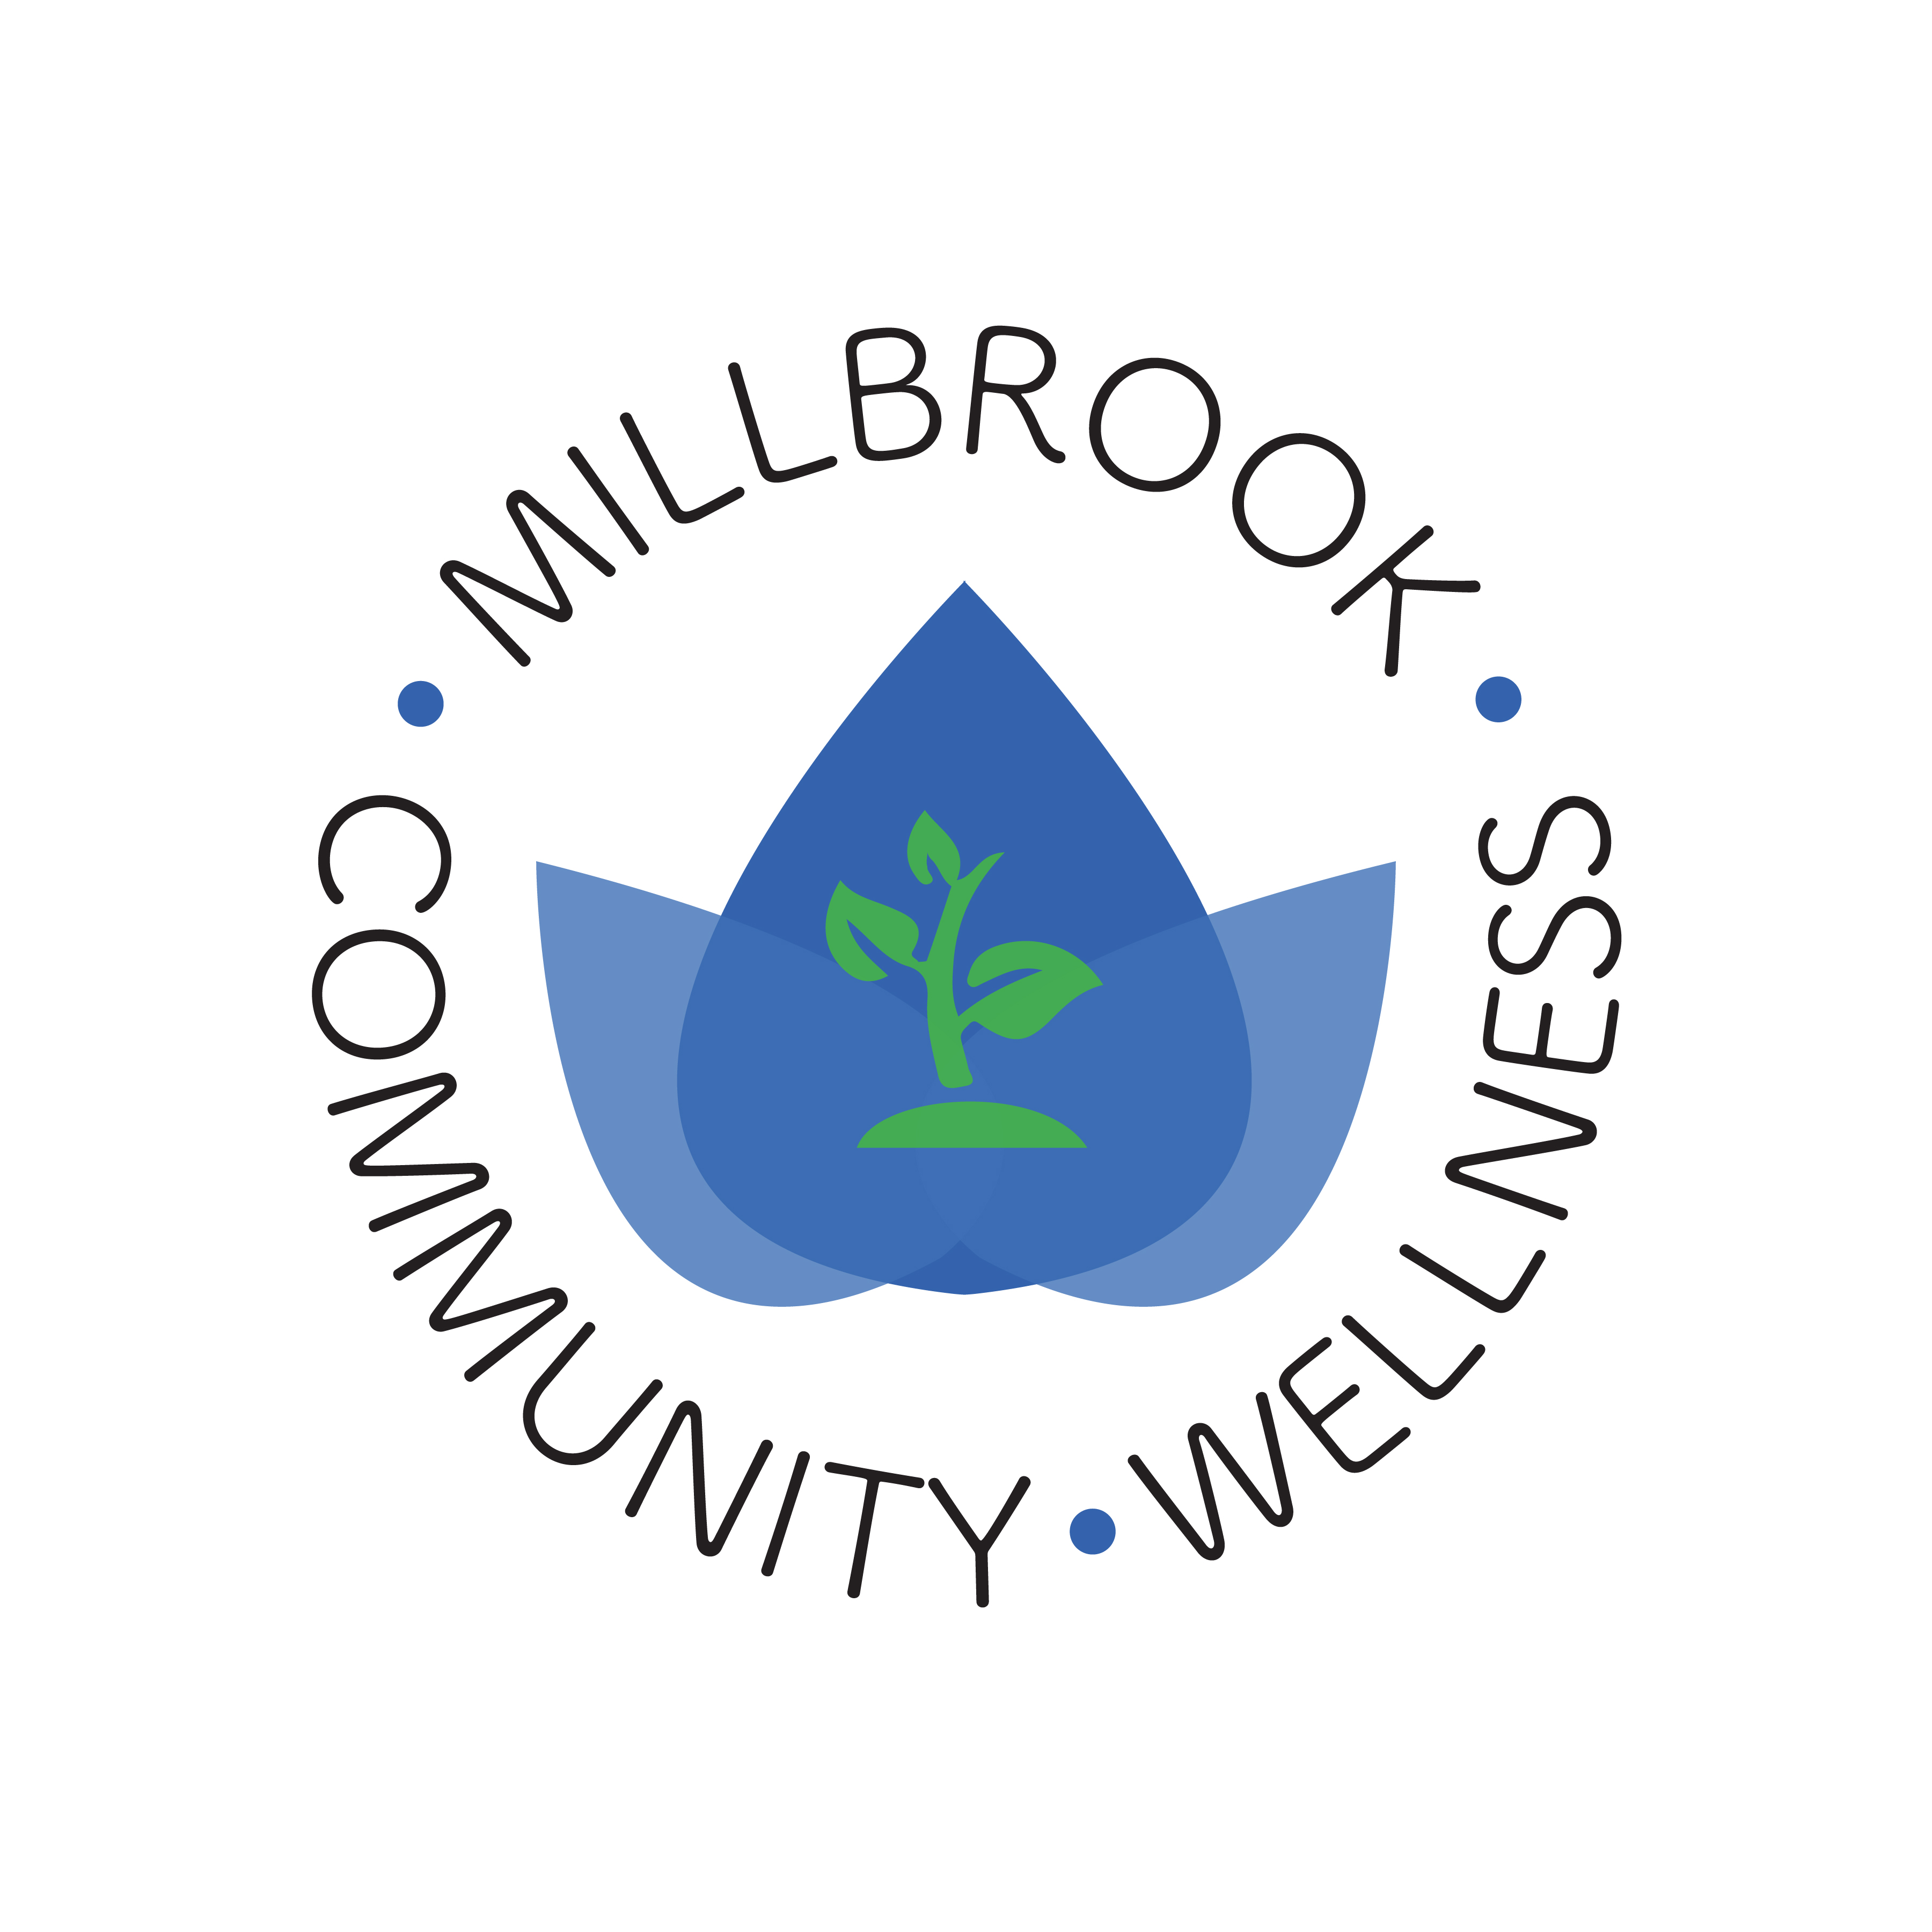
Hay Field ~ $1000+ Sponsorship Level
Your business name attached to a garden bed
Special thanks on our Social Media sites
Your logo and link on our website
Your business name at the entrance of the garden
Dedicate a fruit tree with your name

Corn Maze ~ $500 Sponsorship Level
Special thanks on our Social Media sites
Your logo and link on our website
Your business name at the entrance of the garden
Dedicate a fruit tree with your name

Pumpkin Patch ~ $250 Sponsorship Level
Your logo and link on the website
Your business name at the entrance of the garden
Dedicate a fruit tree with your name

Garden Bed ~ $100 Sponsorship Level
Your business name and link on our website
Your business name at the entrance of the garden

Classroom Greenhouse ~ $50 Sponsorship Level
Your business name and link on our website

Business Name: ________________________________________________________________________

Amount Enclosed: $________________________

Name to appear on signs: _______________________________________________________________

Mailing Address: _______________________________________________________________________

Phone: __________________________________ Email: _______________________________________

Website you would like linked: __________________________________________________________

For all tax-deductible donations, please note:
- Checks should be made payable to FarmOn! (Memo: Millbrook CSD)
- Donation should be mailed to Millbrook CSD, P.O. Box AA, Millbrook, NY 12545
- Please e-mail a jpeg of your logo to WellnessMCSD@Millbrookcsd.org

For more information, contact: 845-677-4200 x 1102
Visit our website for updates: millbrookcommunitywellness.weebly.com

